Buffer Overflow

Dennis Cornwell, Andrew Rockwell, Meredith Schmidt

Buffer overflow classifies a set of attacks in which input is written outside the bounds of the space intended for it, allowing malicious code to be placed into areas where it can be executed. Many variants of attacks can be categorized as buffer overflow, typically
- Stack Overflow
- Heap Overflow
- Integer Overflow
- String Format Abuse
The most common buffer overflow, and the attack focused on in this project, is stack overflow. In a stack overflow, a fixed size array (buffer) is filled using a function that does not validate the size of the array (such as strcpy, gets, or scanf) allowing malicious input to be written past the space allocated for the buffer. In Figure 1, the buffer is located in the local variable space. The goal of malicious input to the function is to overflow past the end of local variables, into the return address. When the function completes, the value of the return address is loaded as the next instruction to be executed. The value placed in the return address space varies between two main types of attacks: the address of malicious code placed on the stack or the address of a function in a linked library.
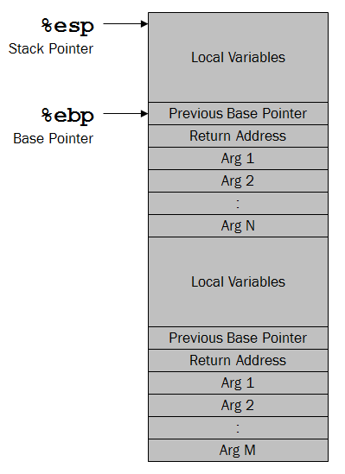
Figure 1: Stack Layout

The original variant of returning to code on the stack requires the attacker to craft byte code performing the operations intended which is passed into the function and then executed when the function returns. The byte code traditionally supplied will launch a shell (aptly referred to as shellcode) allowing the attacker to execute commands as they please on the exploited system. As prevention for buffer overflows became more robust, returning to the stack became a more difficult attack, making popular returning to a linked library function.
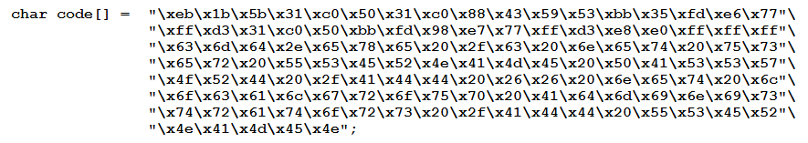
Figure 2: Shellcode

The linked library of choice is the C standard library, which contains the system function, allowing the attacker to execute whatever command string is passed in. As such, this attack is referred to as return to libc. The attacker overruns the buffer and sequentially places the address of system and the two parameters to system: the address to return to after system completes (typically the exit function), and a pointer to the command string to execute (typically “/bin/sh” or “cmd.exe”), on the stack starting at the return address space.
Useful Links
Introduction to buffer overflows and instructions to perform them on Windows: http://www.ma.rhul.ac.uk/static/techrep/2009/RHUL-MA-2009-06.pdf
Walkthrough of a real Windows attack, helpful for attack details: http://www.madirish.net/?article=215
Shellcoding tutorials (only vouching for Windows section): http://www.vividmachines.com/shellcode/shellcode.html

